NAME- SHUBHAM GARG

ENROLL . NO- 9919103057

QUESTION 1

#include<stdio.h>

#include<stdlib.h>

int main()

{

FILE *fp;

int i,n,arr[100],j,temp,ind;

struct book

{

int bookid;

char authorname[20];

int price;

};

printf("enter the no of books whose information u need to add\n");

scanf("%d",&n);

struct book b[n];

fp=fopen("file.c","w");

if(fp==NULL)

{

printf("cant open file\n");

exit(0);

}

for(i=0;i<n;i++)

{

printf("enter Bookid,author name and price of book\n");

scanf("%d%s%d",&b[i].bookid,b[i].authorname,&b[i].price);

fprintf(fp,"%d%s%d",b[i].bookid,b[i].authorname,b[i].price);

fflush(stdin);

}

fclose(fp);

fp=fopen("file.C","r");

if(fp==NULL)

{

printf("cnat open file\n");

exit(0);

}

for(i=0;i<n;i++)

{

arr[i]=fscanf(fp,"%d",&b[i].price);

exit(0);

}

for(i=0;i<n-1;i++)

{

for(j=0;j<n-i-1;j++)

{

if(arr[j]>arr[j+1])

{

temp=arr[j+1];

arr[j+1]=arr[j];

arr[j]=temp;

}

}

}

for(i=0;i<n;i++)

{

if(arr[1]==fscanf(fp,"%d",&b[i].price));

{

printf("displaying the details of book having second min price\n");

fscanf(fp,"%d%s%d",&b[i].bookid,&b[i].authorname,&b[i].price);

printf("bookid %d \n authorname %s \n price %d \n",b[i].bookid,b[i].authorname,b[i].price);

ind=i;

}

}

fclose(fp);

fp=fopen("file.c","a+");

if(fp==NULL)

{

printf("cnt open file\n");

exit(0);

}

fscanf(fp,"%d%s%d",&b[ind].bookid,&b[ind

].authorname,&b[ind].price);

fprintf(fp,"bookid %d \n authorname %s \n price %d \n",b[ind].bookid,b[ind].authorname,b[ind].price);

fclose(fp);

}

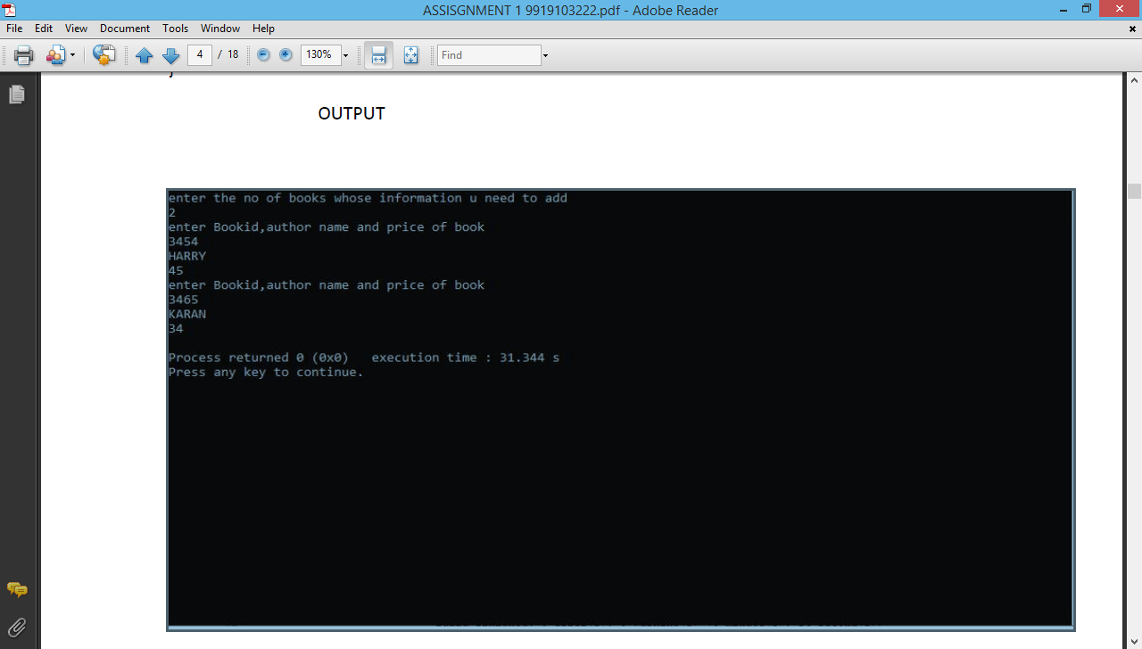

QUESTION-2

#include<stdio.h>

int main()

{

int i,j=0,k=0,l,n,temp,vampire[100],zombie[100],sumv=0,sumz=0,power;

printf("enter the no of creatures\n");

scanf("%d",&n);

printf("enter the power of creatures\n");

for(i=1;i<=n;i++)

{

scanf("%d",&power);

if(power%2==0)

{

zombie[j]=power;

j++;

}

else

{

vampire[k]=power;

k++;

}

}

for(i=0;i<j;i++)

{

for(l=0;l<j-i-1;l++)

{

if(zombie[l]>zombie[l+1])

{

temp=zombie[l+1];

zombie[l+1]=zombie[l];

zombie[l]=temp;

}

}

}

for(i=0;i<k;i++)

{

for(l=0;l<k-i-1;l++)

{

if(vampire[l]>vampire[l+1])

{

temp=vampire[l+1];

vampire[l+1]=vampire[l];

vampire[l]=temp;

}

}

}

for(i=0;i<j;i++)

{

sumz=sumz+zombie[i];

printf("%d\t",zombie[i]);

}

printf("%d\t",sumz);

for(i=0;i<k;i++)

{

sumv=sumv+vampire[i];

printf("%d\t",vampire[i]);

}

printf("%d\t",sumv);

}

OUTPUT

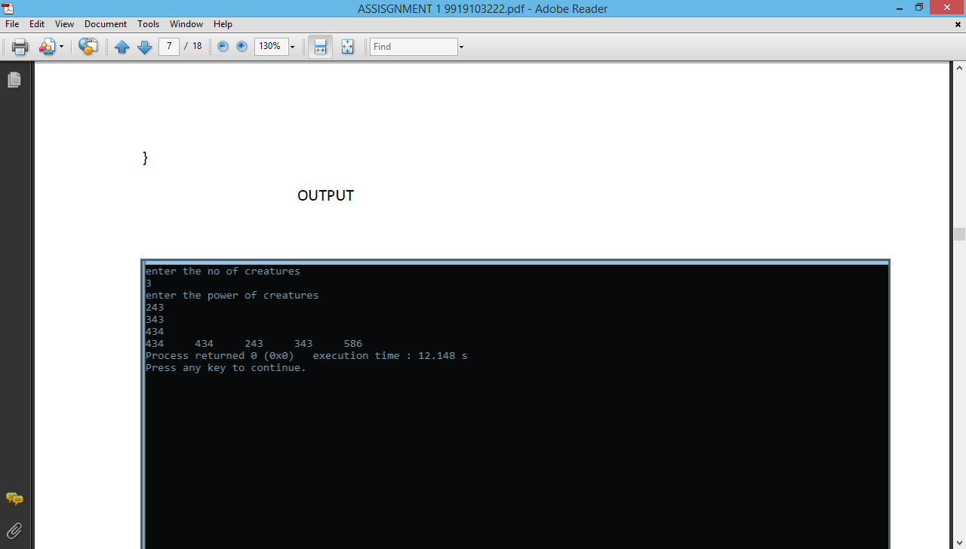

QUESTION-3

#include<stdio.h>

#include<stdlib.h>

struct Node

{

int coeff;

int pow;

struct Node *next;

};

void create_node(int x, int y, struct Node **temp)

{

struct Node *r, *z;

z = *temp;

if(z == NULL)

{

r =(struct Node*)malloc(sizeof(struct Node));

r->coeff = x;

r->pow = y;

*temp = r;

r->next = (struct Node*)malloc(sizeof(struct Node));

r = r->next;

r->next = NULL;

}

else

{

r->coeff = x;

r->pow = y;

r->next = (struct Node*)malloc(sizeof(struct Node));

r = r->next;

r->next = NULL;

}

}

void polyadd(struct Node *poly1, struct Node *poly2, struct Node *poly)

{

while(poly1->next && poly2->next)

{

if(poly1->pow > poly2->pow)

{

poly->pow = poly1->pow;

poly->coeff = poly1->coeff;

poly1 = poly1->next;

}

else if(poly1->pow < poly2->pow)

{

poly->pow = poly2->pow;

poly->coeff = poly2->coeff;

poly2 = poly2->next;

}

else

{

poly->pow = poly1->pow;

poly->coeff = poly1->coeff+poly2->coeff;

poly1 = poly1->next;

poly2 = poly2->next;

}

poly->next = (struct Node *)malloc(sizeof(struct Node));

poly = poly->next;

poly->next = NULL;

}

while(poly1->next || poly2->next)

{

if(poly1->next)

{

poly->pow = poly1->pow;

poly->coeff = poly1->coeff;

poly1 = poly1->next;

}

if(poly2->next)

{

poly->pow = poly2->pow;

poly->coeff = poly2->coeff;

poly2 = poly2->next;

}

poly->next = (struct Node *)malloc(sizeof(struct Node));

poly = poly->next;

poly->next = NULL;

}

}

void show(struct Node *node)

{

while(node->next != NULL)

{

printf("%dx^%d", node->coeff, node->pow);

node = node->next;

if(node->next != NULL)

printf(" + ");

}

}

int main()

{

struct Node *poly1 = NULL, *poly2 = NULL, *poly = NULL;

create_node(5,2,&poly1);

create_node(4,1,&poly1);

create_node(2,0,&poly1);

create_node(5,1,&poly2);

create_node(5,0,&poly2);

printf("1st Number: ");

show(poly1);

printf("\n2nd Number: ");

show(poly2);

poly = (struct Node *)malloc(sizeof(struct Node));

polyadd(poly1, poly2, poly);

printf("\nAdded polynomial: ");

show(poly);

return 0;

}

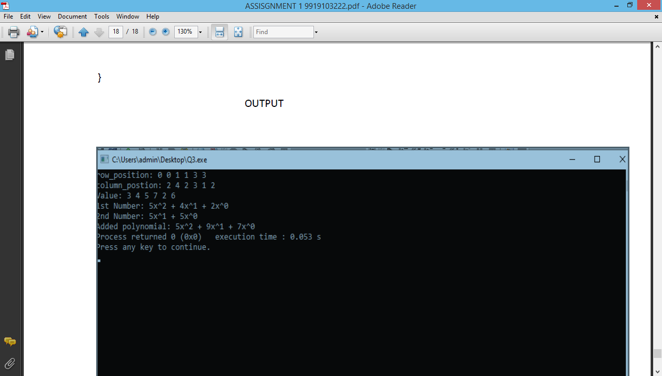

#include<stdio.h>

#include<stdlib.h>

struct Node

{

int value;

int rowpos;

int colpos;

struct Node *next;

};

void createnode(struct Node** start, int val,

int rowindex, int columnindex )

{

struct Node *temp, *r;

temp = *start;

if (temp == NULL)

{

temp = (struct Node *) malloc (sizeof(struct Node));

temp->value =val;

temp->rowpos= rowindex;

temp->colpos= columnindex;

temp->next = NULL;

*start = temp;

}

else

{

while (temp->next != NULL)

temp = temp->next;

r = (struct Node *) malloc (sizeof(struct Node));

r->value = val;

r->rowpos= rowindex;

r->colpos= columnindex;

r->next = NULL;

temp->next = r;

}

}

void PrintList(struct Node* start)

{

struct Node *temp, *r, *s;

temp = r = s = start;

printf("row_position: ");

while(temp != NULL)

{

printf("%d ", temp->rowpos);

temp = temp->next;

}

printf("\n");

printf("column_postion: ");

while(r != NULL)

{

printf("%d ", r->colpos);

r = r->next;

}

printf("\n");

printf("Value: ");

while(s != NULL)

{

printf("%d ", s->value);

s = s->next;

}

printf("\n");

}

int main()

{ int row,col;

printf("Enter no of rows and columns");

scanf("%d %d",&row,&col);

int sparseMatric[row][col];

for(int i=0;i<row;i++)

for(int j=0;j<col;j++)

scanf("%d",&sparseMatric[i][j]);

struct Node* start = NULL;

for (int i = 0; i < row; i++)

for (int j = 0; j < col; j++)

if (sparseMatric[i][j] != 0)

createnode(&start, sparseMatric[i][j], i, j);

PrintList(start);

return 0;

}